No.1

https://github.com/emmilka/question-b-.git
Part A
Grading system
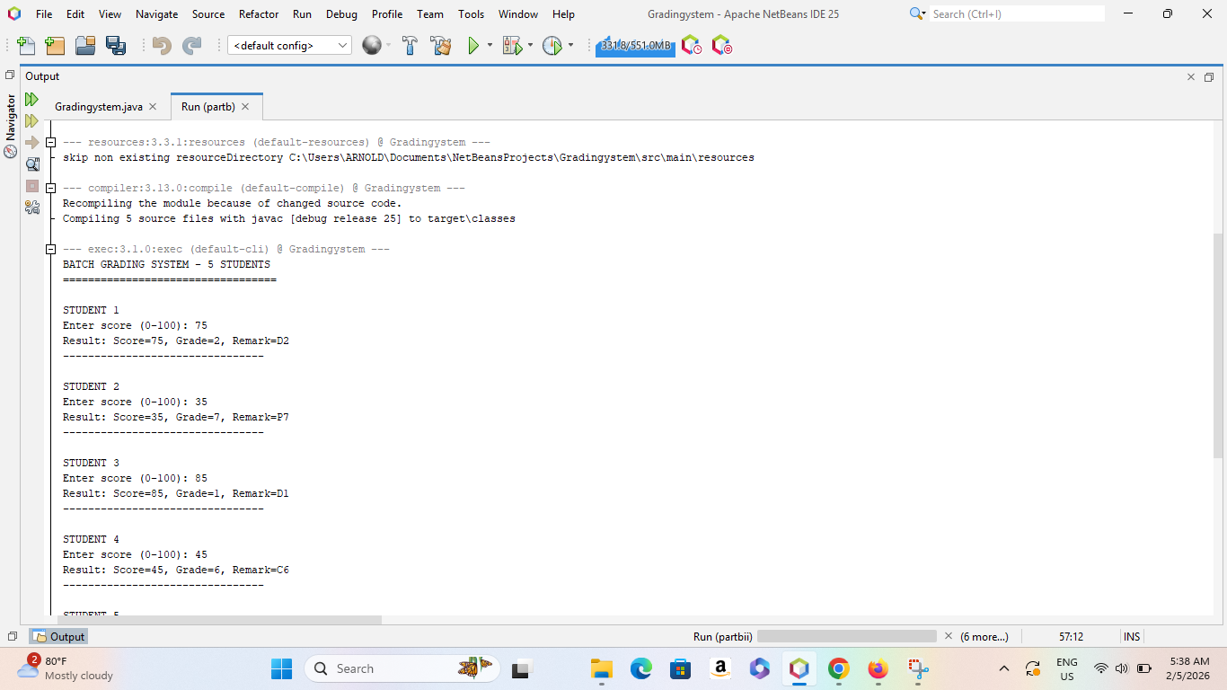
The system processes results for five students in one batch. The program processes students sequentially from Student 1 to Student 5. A loop (likely a for loop) is used to repeat the grading process for each student. This ensures efficiency and avoids code repetition

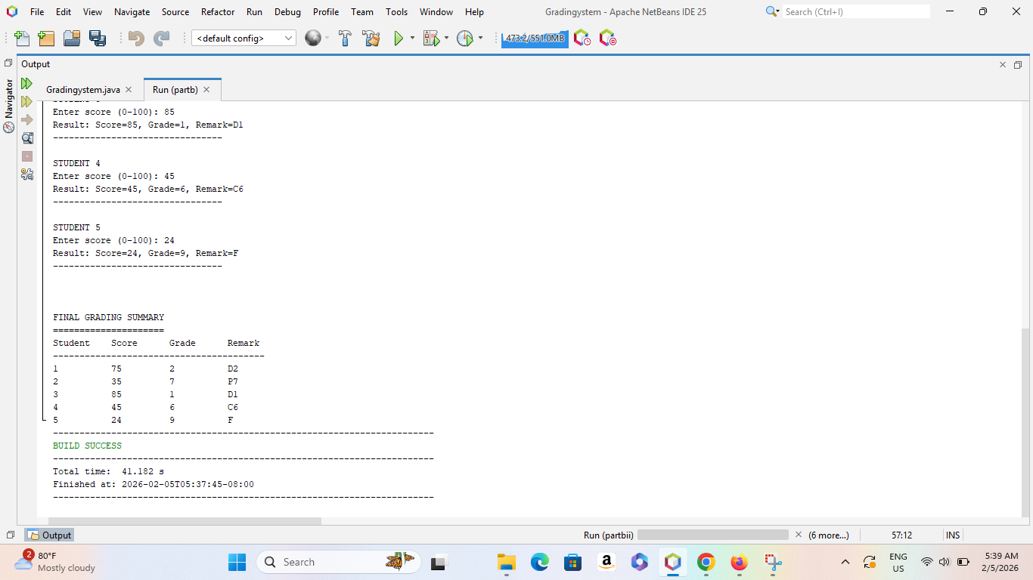
Evaluates the score using if–else conditions, assigns a grade number and determines a remark (e.g., D1, D2, C6, F7, F)

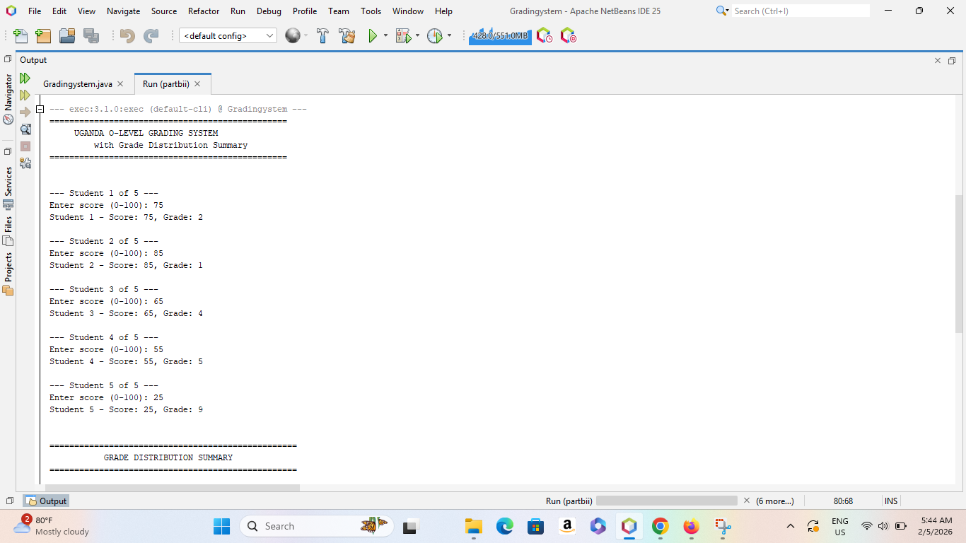
After all student scores are processed, the system displays a Grade Distribution Summary section.
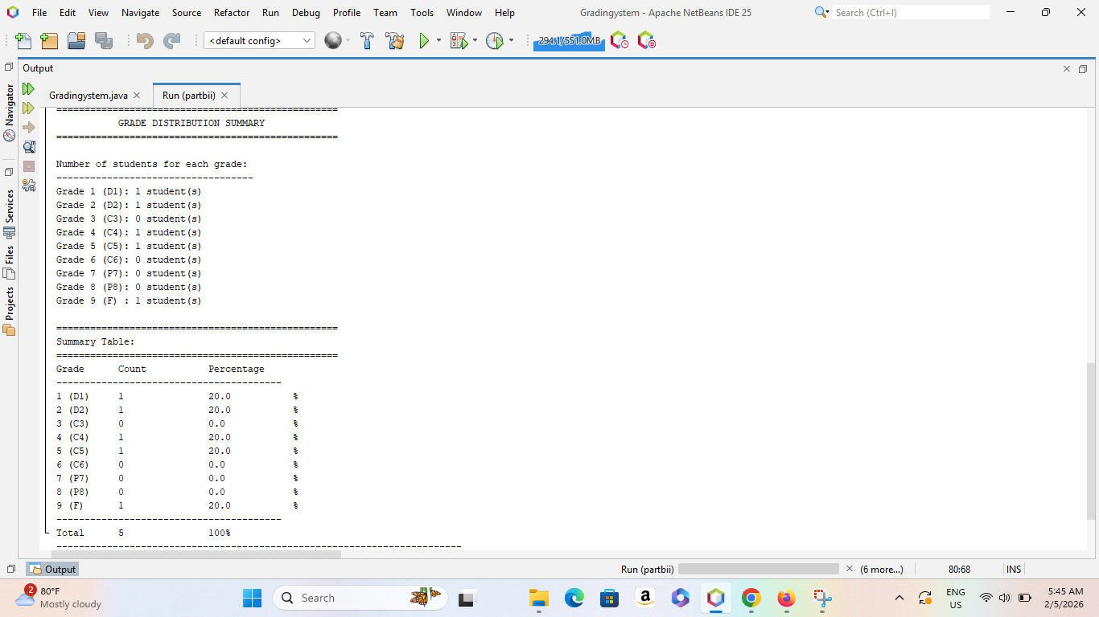

Question one part (b)
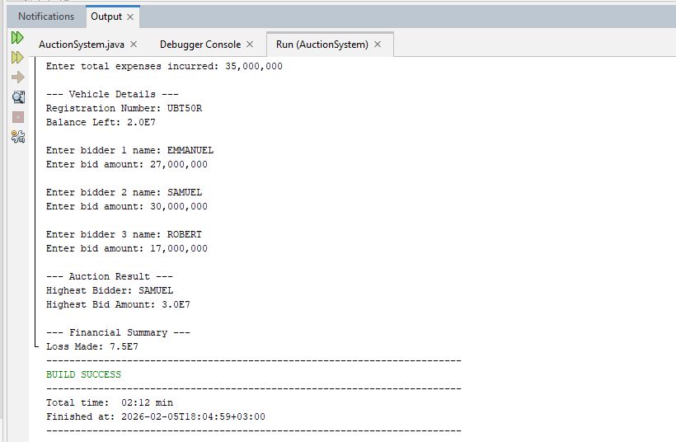
The system allows three bidders to participate in the auction. For each bidder, the program prompts for eg Bidder name, Bid amount. This process is repeated for all three bidders using a loop.
The comparison is done using conditional statements. The bidder with the maximum bid is selected as the winner.

